Dana Mounayer - s23108503
Lab 1 – Big Data Analytics
This report summarizes the steps and results of the Hadoop HDFS lab
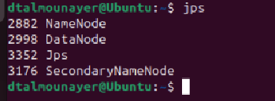

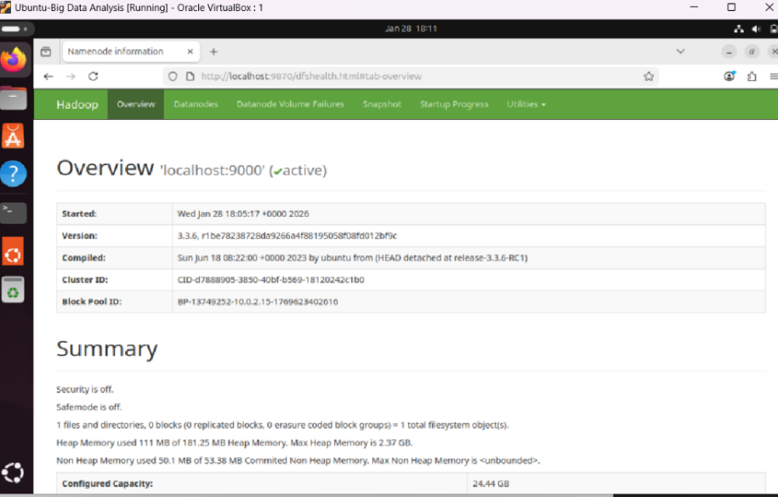

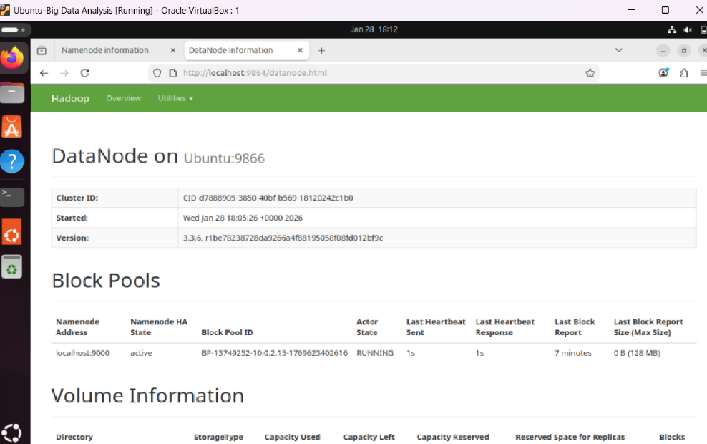
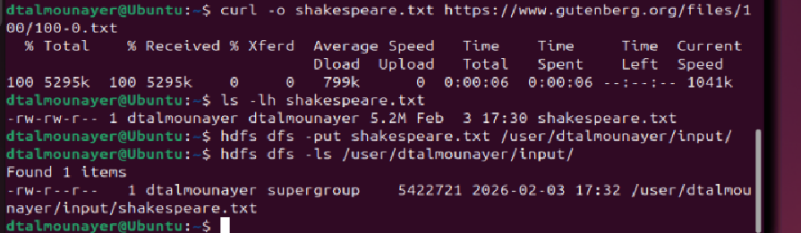
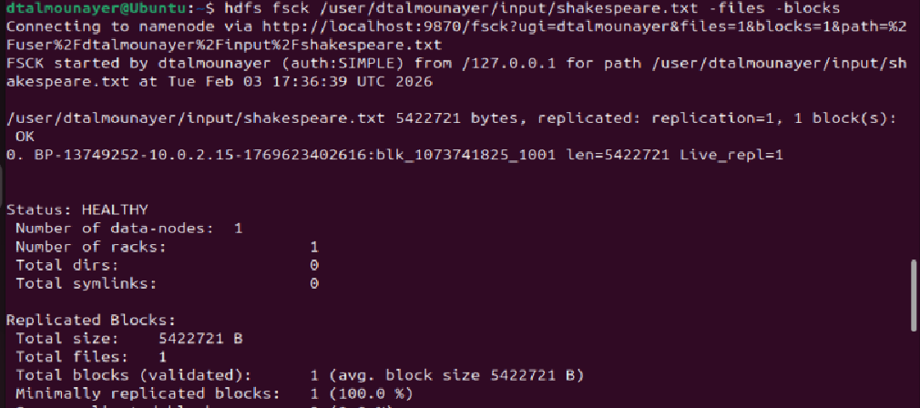

Issues encountered:
Could not access NameNode Web UI from host machine
- Issue: Hadoop was running inside the VM, and localhost from the host points to the host, not the VM.
- Solution: Opened Firefox inside the VM and accessed http://localhost:9870 directly.

- How many blocks was shakespeare.txt split into? 1 block.
- What is the replication factor of your files? 1
- What is the default block size in your configuration? 128 MB.

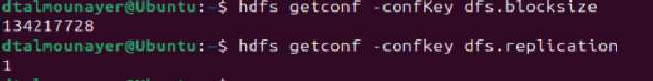

- Why is the replication factor set to 1 in single-node mode?
Because Hadoop runs on a single DataNode, so replication greater than 1 is not possible.

